The Impact of IT Solutions on Preparing Enterprise Systems for Pharmaceutical Product Launches

Kassym-Jomart Tokayev
L.N. Gumilyov Eurasian National University, city of Nur-Sultan

Omar Hassan
Computer Science Department, Qatar University, Qatar

Abstract
The pharmaceutical industry faces significant challenges in launching new drugs, a process that requires meticulous planning and execution across various enterprise systems. IT applications have emerged as critical enablers in ensuring that pharmaceutical companies are well-prepared for these launches. This paper explores the role of IT applications in enhancing readiness for pharmaceutical drug launches, focusing on areas such as supply chain management, regulatory compliance, marketing strategies, and data integration. By leveraging advanced IT solutions, companies can streamline operations, improve coordination, and mitigate risks associated with drug launches. This paper also examines case studies to illustrate the practical benefits of IT applications in this context, highlighting how they contribute to successful and timely market entry. The integration of robust IT infrastructure is essential for managing the complexities of drug launches, ultimately supporting the goal of delivering new therapies to patients efficiently and effectively.
Keywords:

Introduction
Launching a new pharmaceutical drug involves a complex, multi-faceted process that encompasses research and development, regulatory approval, manufacturing, and distribution. Each phase requires precise coordination and compliance with stringent regulations. The readiness of an organization to launch a drug depends on its ability to manage these tasks efficiently. Traditional methods often fall short due to the sheer volume of data and the need for real-time decision-making.
The first step in launching a new pharmaceutical drug is the research and development (R&D) phase, which is typically the most time-consuming and resource-intensive. During this phase, scientists conduct extensive research to identify potential drug candidates. This involves a deep understanding of the disease mechanism, target identification, and the synthesis of compounds that could potentially interact with the target. Preclinical studies are conducted in vitro (in the lab) and in vivo (in animal models) to evaluate the safety and efficacy of these compounds. Data from these studies is meticulously recorded and analyzed to determine the most promising candidates for further development.
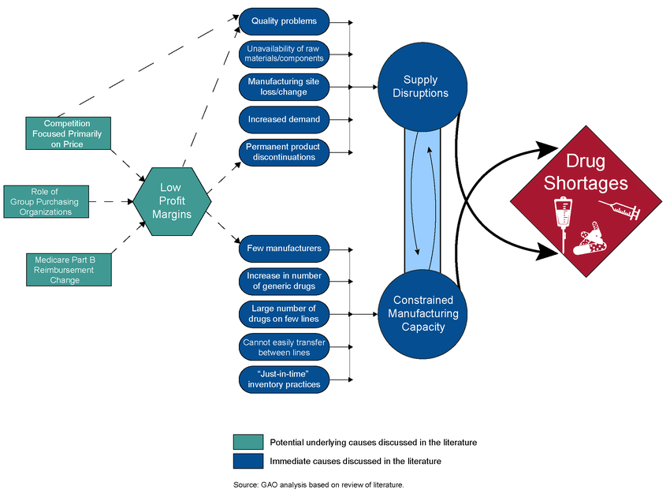
Once a potential drug candidate is identified, it moves into the clinical trial phase, which is divided into three main stages: Phase I, Phase II, and Phase III trials. Phase I trials involve a small group of healthy volunteers and aim to assess the drug’s safety, dosage range, and side effects. If the drug is found to be safe, it progresses to Phase II trials, which involve a larger group of patients and aim to evaluate the drug’s efficacy and optimal dosing. Phase III trials involve an even larger group of patients and aim to confirm the drug’s effectiveness, monitor side effects, and compare it to standard treatments. These trials generate vast amounts of data, which must be meticulously managed and analyzed to ensure regulatory compliance and inform decision-making.
Figure 1. Key Immediate and Potential Underlying Causes of Drug Shortages
Regulatory approval is the next critical step in the drug launch process. This involves submitting a comprehensive dossier to regulatory authorities, such as the U.S. Food and Drug Administration (FDA) or the European Medicines Agency (EMA). The dossier includes detailed information on the drug’s development process, preclinical and clinical trial data, manufacturing processes, and proposed labeling. Regulatory authorities review this information to ensure the drug is safe, effective, and manufactured to high-quality standards. This review process can be lengthy and may involve multiple rounds of questions and requests for additional data from the regulatory authorities.
Once regulatory approval is obtained, the focus shifts to manufacturing and distribution. The drug must be produced in large quantities while maintaining strict quality control standards. This involves scaling up the manufacturing process from the small-scale production used in clinical trials to full-scale commercial production. The manufacturing process must be validated to ensure that each batch of the drug meets the required specifications for purity, potency, and stability. Quality control tests are conducted at various stages of the manufacturing process to ensure compliance with regulatory standards.
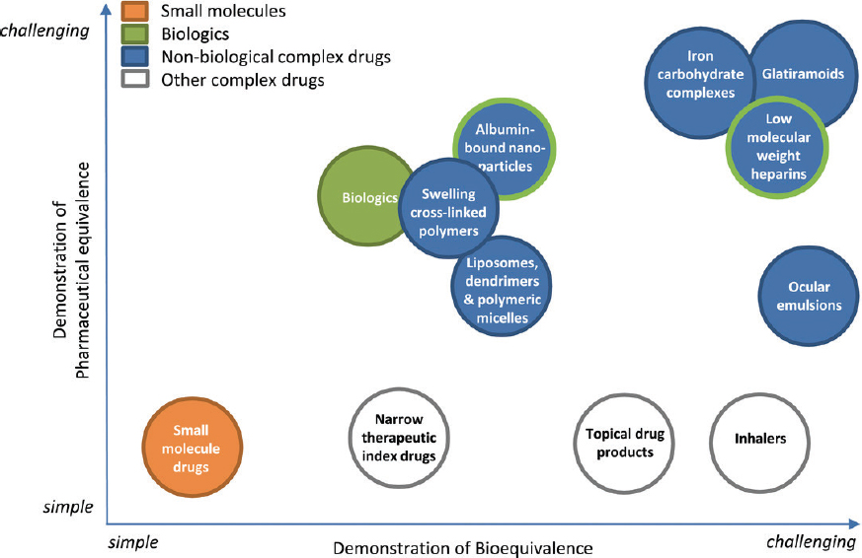
figure 2. Challenges in drug landscape /s

Distribution involves the logistics of getting the drug from the manufacturing facility to the end-users, including healthcare providers and patients. This requires careful planning and coordination to ensure timely delivery and proper storage conditions to maintain the drug’s stability and efficacy. The distribution process must also comply with regulatory requirements for tracking and traceability to prevent counterfeiting and ensure patient safety.

Throughout the entire drug launch process, organizations must manage vast amounts of data and coordinate multiple tasks and stakeholders. Traditional methods of data management and decision-making often fall short due to the sheer volume of data and the need for real-time decision-making. Advanced technologies, such as artificial intelligence (AI) and machine learning, are increasingly being used to streamline data management and enhance decision-making. These technologies can analyze large datasets quickly and accurately, identify patterns and trends, and provide actionable insights to inform decision-making.
In addition to technological advancements, effective project management is crucial for the successful launch of a new pharmaceutical drug. This involves coordinating the activities of various teams, managing timelines and budgets, and ensuring compliance with regulatory requirements. Project managers must have a deep understanding of the drug development process and the regulatory landscape, as well as strong organizational and communication skills to coordinate the efforts of multiple stakeholders.
Another important aspect of launching a new pharmaceutical drug is stakeholder engagement. This includes engaging with regulatory authorities, healthcare providers, patients, and payers to ensure that the drug meets their needs and expectations. Early and ongoing engagement with these stakeholders can help to identify potential issues and address them proactively. For example, engaging with regulatory authorities early in the development process can help to clarify regulatory requirements and streamline the approval process. Engaging with healthcare providers and patients can provide valuable insights into the drug’s clinical benefits and potential side effects, which can inform the development of educational materials and marketing strategies.
Market access and pricing strategies are also critical for the successful launch of a new pharmaceutical drug. This involves assessing the competitive landscape, understanding the value proposition of the drug, and developing pricing strategies that reflect the drug’s clinical benefits and economic value. Market access strategies may also involve negotiating with payers to secure reimbursement for the drug, which is essential for ensuring that patients have access to the drug.
Post-launch activities are equally important for the long-term success of a new pharmaceutical drug. This includes ongoing monitoring of the drug’s safety and efficacy through pharmacovigilance programs, as well as conducting post-marketing studies to gather additional data on the drug’s real-world performance. Post-launch activities also involve continuing engagement with healthcare providers, patients, and payers to gather feedback and address any issues that arise.
In conclusion, launching a new pharmaceutical drug is a complex, multi-faceted process that involves numerous stages, from research and development to regulatory approval, manufacturing, and distribution. Each stage requires precise coordination and compliance with stringent regulations. The readiness of an organization to launch a drug depends on its ability to manage these tasks efficiently and effectively. Traditional methods of data management and decision-making often fall short due to the sheer volume of data and the need for real-time decision-making. Advanced technologies, such as AI and machine learning, and effective project management are essential for streamlining the drug launch process and ensuring its success. Stakeholder engagement, market access strategies, and post-launch activities are also critical for the long-term success of a new pharmaceutical drug.
The advent of IT applications has revolutionized many aspects of pharmaceutical operations. Advanced enterprise systems, including Enterprise Resource Planning (ERP), Customer Relationship Management (CRM), and specialized supply chain management software, play pivotal roles in ensuring that all components of the drug launch process are aligned and executed flawlessly. These systems help organizations manage data, comply with regulations, coordinate activities across departments, and respond to market dynamics swiftly.
ERP systems have become the backbone of operational efficiency in the pharmaceutical industry. They integrate various business processes, including finance, procurement, manufacturing, and human resources, into a single unified system. This integration enables organizations to have a real-time view of their operations, streamline workflows, and make informed decisions quickly. In the context of a drug launch, ERP systems facilitate the coordination of complex processes such as production planning, inventory management, and quality control. They ensure that all resources are allocated efficiently and that any issues are identified and addressed promptly.
CRM systems, on the other hand, are crucial for managing interactions with healthcare providers, patients, and other stakeholders. These systems store detailed information about customer interactions, preferences, and feedback, which can be leveraged to tailor marketing strategies and improve customer engagement. During the drug launch process, CRM systems help pharmaceutical companies to segment their target audience, track the effectiveness of their marketing campaigns, and gather valuable insights from customer feedback. This information is vital for refining product positioning and ensuring that the new drug meets the needs and expectations of its users.
Specialized supply chain management software plays an essential role in ensuring the efficient distribution of pharmaceutical products. These systems provide end-to-end visibility into the supply chain, from raw material procurement to the delivery of finished products. They enable organizations to optimize inventory levels, reduce lead times, and minimize the risk of stockouts or overstock situations. In the pharmaceutical industry, where the timely delivery of products can significantly impact patient health, having a robust supply chain management system is crucial. These systems also ensure compliance with regulatory requirements related to product traceability and serialization, which are critical for preventing counterfeiting and ensuring patient safety.
One of the key advantages of advanced IT applications in pharmaceutical operations is their ability to manage and analyze large volumes of data. The drug launch process generates a vast amount of data, from clinical trial results and regulatory submissions to manufacturing and distribution records. Traditional methods of data management are often inadequate for handling this volume and complexity of data. Advanced enterprise systems, equipped with data analytics capabilities, can process and analyze this data in real-time, providing actionable insights that inform decision-making at every stage of the drug launch process. For instance, predictive analytics can help identify potential risks and opportunities, enabling organizations to take proactive measures to mitigate risks and capitalize on opportunities.
Compliance with regulatory requirements is another critical aspect of the drug launch process. Regulatory authorities such as the FDA and EMA have stringent requirements for the approval and monitoring of pharmaceutical products. Advanced IT systems help organizations to ensure compliance with these requirements by providing tools for document management, audit trails, and electronic submissions. These systems automate many of the compliance-related tasks, reducing the risk of human error and ensuring that all documentation is accurate and up-to-date. They also facilitate communication with regulatory authorities, enabling organizations to respond to queries and provide additional information quickly.
The coordination of activities across different departments is essential for the successful launch of a new drug. Advanced enterprise systems provide a centralized platform for communication and collaboration, ensuring that all departments are aligned and working towards the same goals. For example, ERP systems can synchronize production schedules with marketing campaigns, ensuring that there is sufficient inventory to meet anticipated demand. CRM systems can facilitate collaboration between sales and marketing teams, enabling them to develop targeted strategies that resonate with their audience. Supply chain management systems can coordinate logistics activities, ensuring that products are delivered to the right place at the right time.
The ability to respond swiftly to market dynamics is another significant benefit of advanced IT applications in pharmaceutical operations. The pharmaceutical industry is highly dynamic, with new competitors, changing regulations, and evolving customer needs. Advanced enterprise systems provide organizations with the agility to adapt to these changes quickly. For example, real-time data analytics can help organizations to monitor market trends and adjust their strategies accordingly. CRM systems can track customer feedback and identify emerging needs, enabling organizations to develop new products or modify existing ones to better meet these needs. Supply chain management systems can optimize logistics operations to respond to changes in demand or disruptions in the supply chain.
In conclusion, the advent of IT applications has revolutionized pharmaceutical operations, making the drug launch process more efficient, compliant, and responsive to market dynamics. Advanced enterprise systems, including ERP, CRM, and specialized supply chain management software, play pivotal roles in managing data, coordinating activities, and ensuring regulatory compliance. These systems provide the tools and capabilities needed to navigate the complexities of the drug launch process, from research and development to manufacturing and distribution. By leveraging these advanced IT applications, pharmaceutical companies can enhance their operational efficiency, improve customer engagement, and achieve a successful drug launch.

IT Applications Enhancing Drug Launch Readiness
The advent of IT applications has significantly transformed various aspects of pharmaceutical operations, particularly in supply chain management, regulatory compliance, customer relationship management, and data integration and analytics. Advanced systems such as Supply Chain Management (SCM) systems, Regulatory Compliance Management systems, Customer Relationship Management (CRM) systems, and data analytics tools are now essential for ensuring the seamless execution of the drug launch process. These technologies enable organizations to manage data efficiently, comply with regulations, coordinate activities across departments, and respond swiftly to market dynamics.
Category | Features
Supply Chain Management (SCM) Systems | - Inventory Management: Advanced SCM systems allow for real-time tracking of raw materials and finished products, ensuring that inventory levels are optimized and that there are no delays in production or distribution. - Logistics and Distribution: These systems help in planning and executing logistics strategies, ensuring that drugs are delivered to the market on time. They also provide visibility into the entire supply chain, allowing for proactive problem-solving.
Regulatory Compliance Management | - Electronic Submission Systems: IT applications facilitate the electronic submission of regulatory documents, ensuring that all necessary approvals are obtained efficiently. This reduces the time and effort required for compliance and minimizes the risk of errors. - Compliance Tracking: These systems track changes in regulatory requirements and ensure that all processes and documentation remain compliant with current laws, thereby avoiding potential delays or penalties.
Customer Relationship Management (CRM) Systems | - Market Analysis and Segmentation: CRM systems provide insights into market trends and customer preferences, allowing pharmaceutical companies to tailor their marketing strategies effectively. They help in identifying key stakeholders and influencers within the healthcare sector. - Sales Force Automation: These tools streamline the activities of sales teams, ensuring that they have access to the latest product information and marketing materials, thus enhancing their efficiency and effectiveness.
Data Integration and Analytics | - Real-time Data Access: Integrating various enterprise systems provides a holistic view of operations, facilitating real-time decision-making. This integration ensures that all departments are working with the same up-to-date information. - Predictive Analytics: Advanced analytics can forecast market demand, identify potential bottlenecks, and recommend strategies to mitigate risks. This helps in planning the launch timeline and resource allocation more effectively.

Supply Chain Management (SCM) systems play a crucial role in optimizing the pharmaceutical supply chain. These systems enable real-time tracking of raw materials and finished products, ensuring that inventory levels are maintained at optimal levels to prevent any delays in production or distribution. Advanced SCM systems use sophisticated algorithms to predict inventory needs, automate reordering processes, and manage warehouse operations efficiently. This real-time visibility into inventory levels allows pharmaceutical companies to respond promptly to changes in demand, avoid stockouts, and reduce excess inventory, ultimately enhancing the efficiency of the supply chain.
Logistics and distribution are other critical areas where SCM systems make a significant impact. These systems assist in planning and executing logistics strategies to ensure that drugs are delivered to the market on time. They provide end-to-end visibility into the entire supply chain, enabling proactive problem-solving and ensuring that any potential disruptions are identified and addressed promptly. With advanced SCM systems, pharmaceutical companies can optimize their transportation routes, manage carrier performance, and ensure compliance with regulatory requirements related to the storage and transportation of drugs. This comprehensive approach to logistics and distribution helps in maintaining the integrity of pharmaceutical products and ensuring their timely delivery to healthcare providers and patients.
Regulatory Compliance Management is another vital aspect of pharmaceutical operations that has been revolutionized by IT applications. Electronic submission systems are a key component of these IT solutions, facilitating the efficient and accurate submission of regulatory documents. These systems streamline the process of obtaining necessary approvals from regulatory authorities, reducing the time and effort required for compliance. By automating the submission process, pharmaceutical companies can minimize the risk of errors and ensure that all documentation is complete and accurate, thus accelerating the regulatory approval process.
Compliance tracking systems are also essential for ensuring that pharmaceutical companies remain compliant with evolving regulatory requirements. These systems monitor changes in laws and regulations and ensure that all processes and documentation are updated accordingly. This proactive approach to compliance management helps companies avoid potential delays or penalties associated with non-compliance. By maintaining up-to-date records and ensuring that all regulatory requirements are met, these systems provide a robust framework for managing regulatory compliance throughout the drug launch process.
Customer Relationship Management (CRM) systems have become indispensable tools for pharmaceutical companies in managing their interactions with healthcare providers, patients, and other stakeholders. CRM systems provide valuable insights into market trends and customer preferences, enabling companies to tailor their marketing strategies effectively. Through market analysis and segmentation, these systems help identify key stakeholders and influencers within the healthcare sector, allowing for targeted marketing campaigns that resonate with the intended audience. By understanding the needs and preferences of different market segments, pharmaceutical companies can develop more effective marketing strategies and improve their overall market penetration.
Sales force automation is another critical feature of CRM systems that enhances the efficiency and effectiveness of sales teams. These tools streamline the activities of sales representatives by providing them with access to the latest product information, marketing materials, and customer data. By automating routine tasks such as scheduling appointments, tracking sales activities, and generating reports, CRM systems enable sales teams to focus on building relationships with healthcare providers and driving sales. This increased efficiency not only improves the productivity of sales teams but also enhances the overall customer experience by ensuring that healthcare providers receive timely and relevant information about new drugs.
Data integration and analytics are at the heart of modern pharmaceutical operations, providing a holistic view of the entire drug launch process. Integrating various enterprise systems ensures that all departments are working with the same up-to-date information, facilitating real-time decision-making. Real-time data access enables organizations to monitor key performance indicators, track progress against goals, and make informed decisions quickly. This integration eliminates data silos and ensures that all stakeholders have access to accurate and consistent information, enhancing coordination and collaboration across departments.
Predictive analytics is another powerful tool enabled by advanced IT applications. By analyzing historical data and identifying patterns and trends, predictive analytics can forecast market demand, identify potential bottlenecks, and recommend strategies to mitigate risks. This capability is particularly valuable in the planning phase of a drug launch, where accurate demand forecasting and resource allocation are critical for success. Predictive analytics can help pharmaceutical companies optimize their production schedules, allocate resources efficiently, and develop contingency plans to address potential challenges. This data-driven approach to planning and decision-making enhances the overall effectiveness of the drug launch process and improves the likelihood of a successful market introduction.
In conclusion, the integration of advanced IT applications has revolutionized various aspects of pharmaceutical operations, from supply chain management and regulatory compliance to customer relationship management and data analytics. Supply Chain Management (SCM) systems optimize inventory management and logistics, ensuring that drugs are produced and delivered efficiently. Regulatory Compliance Management systems streamline the submission and tracking of regulatory documents, ensuring compliance with evolving regulations. Customer Relationship Management (CRM) systems provide valuable insights into market trends and customer preferences, enhancing marketing strategies and sales force efficiency. Data integration and analytics enable real-time decision-making and predictive planning, ensuring that all departments are aligned and working towards the same goals. By leveraging these advanced IT applications, pharmaceutical companies can enhance their operational efficiency, ensure regulatory compliance, and achieve successful drug launches in a dynamic and competitive market.

Ensuring Readiness Through IT Applications
Ensuring readiness for a pharmaceutical drug launch is a multifaceted endeavor that demands the integration of advanced IT applications. These applications span various aspects, including integrated project management, communication and collaboration platforms, risk management, and leveraging case studies to highlight successful implementations. By employing these IT solutions, pharmaceutical companies can coordinate complex processes, enhance communication, manage risks effectively, and draw insights from real-world examples to ensure a smooth and successful drug launch.
Integrated project management tools are indispensable in coordinating the myriad tasks involved in a drug launch. Effective project management ensures that cross-functional teams can collaborate seamlessly, track progress, and address issues promptly. These tools offer a centralized platform where all project-related information, timelines, and tasks can be managed efficiently. For instance, tools like Microsoft Project or Asana provide features such as Gantt charts, task assignments, and progress tracking, which are crucial for maintaining alignment among various departments. By using these tools, pharmaceutical companies can ensure that every phase of the drug launch, from research and development to marketing and distribution, is executed according to plan. This integrated approach not only improves efficiency but also enhances accountability and transparency within the organization.
Category | Features
Integrated Project Management | - Effective project management tools are essential for coordinating the myriad tasks involved in a drug launch. These tools enable cross-functional teams to collaborate seamlessly, track progress, and address issues promptly.
Communication and Collaboration Platforms | - Platforms like Microsoft Teams, Slack, and other collaboration tools facilitate communication across different departments and geographies. They ensure that all stakeholders are aligned and informed, reducing the risk of miscommunication.
Risk Management | - IT applications help in identifying and managing risks associated with drug launches. Risk management tools can predict potential issues, assess their impact, and develop mitigation strategies, thereby ensuring a smoother launch process.
Case Studies | - Case Study 1: A major pharmaceutical company successfully launched a new drug by using an integrated ERP system that coordinated activities across research, production, and marketing departments. This system ensured that all regulatory requirements were met and that the product reached the market on time. - Case Study 2: Another company used advanced analytics to predict market demand for a new therapy, allowing them to scale production accordingly and avoid shortages or overproduction. This proactive approach was facilitated by their robust IT infrastructure, which integrated data from various sources for comprehensive analysis.

Communication and collaboration platforms play a critical role in facilitating effective communication across different departments and geographies. Platforms like Microsoft Teams, Slack, and other collaboration tools enable real-time communication and information sharing, ensuring that all stakeholders are aligned and informed. These tools support various forms of communication, including instant messaging, video conferencing, and document sharing, which are essential for maintaining seamless collaboration. For example, during a drug launch, team members from research, regulatory, manufacturing, and marketing can use these platforms to share updates, discuss issues, and make decisions collaboratively. This reduces the risk of miscommunication and ensures that everyone is on the same page, thereby enhancing the overall efficiency of the launch process.
Risk management is another critical area where IT applications provide significant benefits. The drug launch process is fraught with potential risks, including regulatory hurdles, production delays, and market uncertainties. Risk management tools help in identifying and managing these risks effectively. These tools can predict potential issues by analyzing historical data and current trends, assess their impact, and develop mitigation strategies to address them. For example, a risk management system might use advanced analytics to forecast potential delays in production due to supply chain disruptions and suggest alternative sourcing strategies. By proactively managing risks, pharmaceutical companies can ensure a smoother launch process and avoid costly setbacks.
Real-world case studies highlight the practical benefits of using IT applications in drug launches. In one notable case, a major pharmaceutical company successfully launched a new drug by leveraging an integrated ERP system. This system coordinated activities across research, production, and marketing departments, ensuring that all regulatory requirements were met and that the product reached the market on time. The ERP system provided real-time visibility into the progress of various tasks, enabling the company to address issues promptly and maintain compliance with regulatory standards. This case study demonstrates how integrated IT solutions can enhance operational efficiency and ensure a successful drug launch.
In another case, a pharmaceutical company used advanced analytics to predict market demand for a new therapy. By analyzing data from various sources, including market trends, patient demographics, and sales forecasts, the company was able to scale production accordingly and avoid shortages or overproduction. This proactive approach was facilitated by their robust IT infrastructure, which integrated data from multiple sources for comprehensive analysis. The use of predictive analytics not only optimized production but also ensured that the company could meet market demand effectively, thereby maximizing the success of the drug launch.
In conclusion, ensuring readiness for a pharmaceutical drug launch requires the strategic integration of advanced IT applications. Integrated project management tools are essential for coordinating complex tasks and ensuring cross-functional collaboration. Communication and collaboration platforms facilitate real-time information sharing and alignment among stakeholders. Risk management tools help in identifying and mitigating potential issues, ensuring a smoother launch process. Real-world case studies provide valuable insights into the practical benefits of using IT solutions, highlighting successful implementations and their positive impact on drug launches. By leveraging these IT applications, pharmaceutical companies can enhance their operational efficiency, manage risks effectively, and ensure the successful launch of new drugs in a competitive market.

Conclusion
The role of IT applications in ensuring readiness for pharmaceutical drug launches cannot be overstated. By leveraging advanced technologies such as Supply Chain Management (SCM), Customer Relationship Management (CRM), and predictive analytics, pharmaceutical companies can streamline their operations, enhance regulatory compliance, and improve market responsiveness. The successful integration of these IT solutions into enterprise systems is crucial for managing the complexities of drug launches, ultimately leading to more efficient and effective delivery of new therapies to patients. Future research should focus on developing more sophisticated IT tools and exploring their applications in other aspects of pharmaceutical operations to further enhance industry capabilities.
Integrated project management is a critical component in ensuring readiness for drug launches. Effective project management tools enable cross-functional teams to collaborate seamlessly, track progress, and address issues promptly. These tools provide a centralized platform for managing tasks, timelines, and resources, ensuring that all departments involved in the drug launch process are aligned and working towards common goals. For example, project management software such as Microsoft Project or Trello offers features like Gantt charts, task assignments, and real-time progress tracking, which help in coordinating activities across research, development, regulatory, production, and marketing teams. This integration fosters transparency, accountability, and timely decision-making, all of which are essential for a successful drug launch.
Communication and collaboration platforms are indispensable for facilitating effective communication across different departments and geographical locations. Platforms like Microsoft Teams, Slack, and other collaboration tools ensure that all stakeholders are informed and aligned, thereby reducing the risk of miscommunication. These platforms support various forms of communication, including instant messaging, video conferencing, and document sharing, which are crucial for maintaining seamless collaboration. During a drug launch, team members from different functions can use these platforms to share updates, discuss challenges, and make decisions collectively. This real-time communication capability enhances coordination and ensures that any issues are promptly addressed, leading to a more efficient launch process.
Risk management is another critical area where IT applications provide substantial benefits. The drug launch process is inherently complex and fraught with potential risks, such as regulatory hurdles, production delays, and market fluctuations. Risk management tools help in identifying, assessing, and mitigating these risks effectively. These tools use advanced analytics to predict potential issues by analyzing historical data and current trends, allowing pharmaceutical companies to develop proactive mitigation strategies. For instance, risk management systems can forecast supply chain disruptions and suggest alternative sourcing strategies to ensure continuous production. By managing risks proactively, companies can minimize disruptions and ensure a smoother drug launch process.
Case studies illustrate the practical benefits of using IT applications in pharmaceutical drug launches. In one case, a major pharmaceutical company successfully launched a new drug by using an integrated ERP system that coordinated activities across research, production, and marketing departments. The ERP system provided real-time visibility into all aspects of the drug launch process, ensuring that all regulatory requirements were met and that the product reached the market on time. This system enabled the company to address any issues promptly and maintain compliance with stringent regulatory standards, demonstrating how integrated IT solutions can enhance operational efficiency and ensure successful drug launches.
In another case, a pharmaceutical company used advanced analytics to predict market demand for a new therapy. By integrating data from various sources, including market trends, patient demographics, and sales forecasts, the company was able to scale production accordingly and avoid shortages or overproduction. This proactive approach was facilitated by their robust IT infrastructure, which enabled comprehensive data analysis and informed decision-making. The use of predictive analytics optimized production processes and ensured that the company could meet market demand effectively, thereby maximizing the success of the drug launch.
The integration of SCM, CRM, and predictive analytics into enterprise systems plays a pivotal role in streamlining pharmaceutical operations. SCM systems enhance inventory management and logistics, ensuring that raw materials and finished products are available when needed and that they are delivered to the market on time. CRM systems provide insights into market trends and customer preferences, enabling pharmaceutical companies to tailor their marketing strategies and engage more effectively with healthcare providers and patients. Predictive analytics offer valuable forecasts and recommendations, helping companies plan their production schedules, allocate resources efficiently, and develop contingency plans to address potential challenges.
Future research should focus on developing more sophisticated IT tools and exploring their applications in other aspects of pharmaceutical operations to further enhance industry capabilities. For example, advancements in artificial intelligence and machine learning could lead to the development of more intelligent risk management systems that can predict and mitigate risks with greater accuracy. Similarly, the integration of blockchain technology into supply chain management could enhance traceability and security, ensuring that pharmaceutical products are authentic and safely delivered to patients. [1] [2], [3] [4] [5], [6] [7] [8], [9] [10]

References
[1] U. Desale, “The initiation of a pharmaceutical drug launch and its preparation within enterprise systems of Supply chain,” 2023.
[2] B. Ramadan, M. Metni, G. Hamadeh, M. Kurdi, and R. Karam, “Requirements for a Successful Drug Launch in Small Markets: A Pilot Study in Lebanon,” Value Health Reg Issues, vol. 19, pp. 59–64, Sep. 2019.
[3] N. Rajora, “Pharmaceutical drug launch and its readiness in enterprise systems,” Aquat. Microb. Ecol., 2022.
[4] U. Desale, “Critical Regulatory Controls within Pharmaceutical Corporation,” Available at SSRN 4586967, 2023.
[5] I. Verniers, S. Stremersch, and C. Croux, “The global entry of new pharmaceuticals: A joint investigation of launch window and price,” Int. J. Res. Nurs., 2011.
[6] N. Houy and I. Jelovac, “Drug Launch Timing and International Reference Pricing,” Health Econ., vol. 24, no. 8, pp. 978–989, Aug. 2015.
[7] M. Matikainen, T. Rajalahti, and M. Peltoniemi, “Determinants of new product launch success in the pharmaceutical industry,” of Pharmaceutical …, 2015.
[8] N. Varol, J. Costa-Font, and A. McGuire, “Do international launch strategies of pharmaceutical corporations respond to changes in the regulatory environment?,” The LSE Companion to Health, 2012.
[9] K. R. N. Hansen and M. Grunow, “Planning operations before market launch for balancing time-to-market and risks in pharmaceutical supply chains,” Int. J. Prod. Econ., 2015.
[10] C. Schlegel, “How to make your drug launch A success,” 2017.

